The Art Gallery Sales Tracking System

A system for 100 artists, 1000 pieces, 5000 customers per year Phase 1

Gabelli School of Business

Fordham University

Yifan Ren

Sui Xin

Jian Shen

Chang Liu

**E-R Diagram**

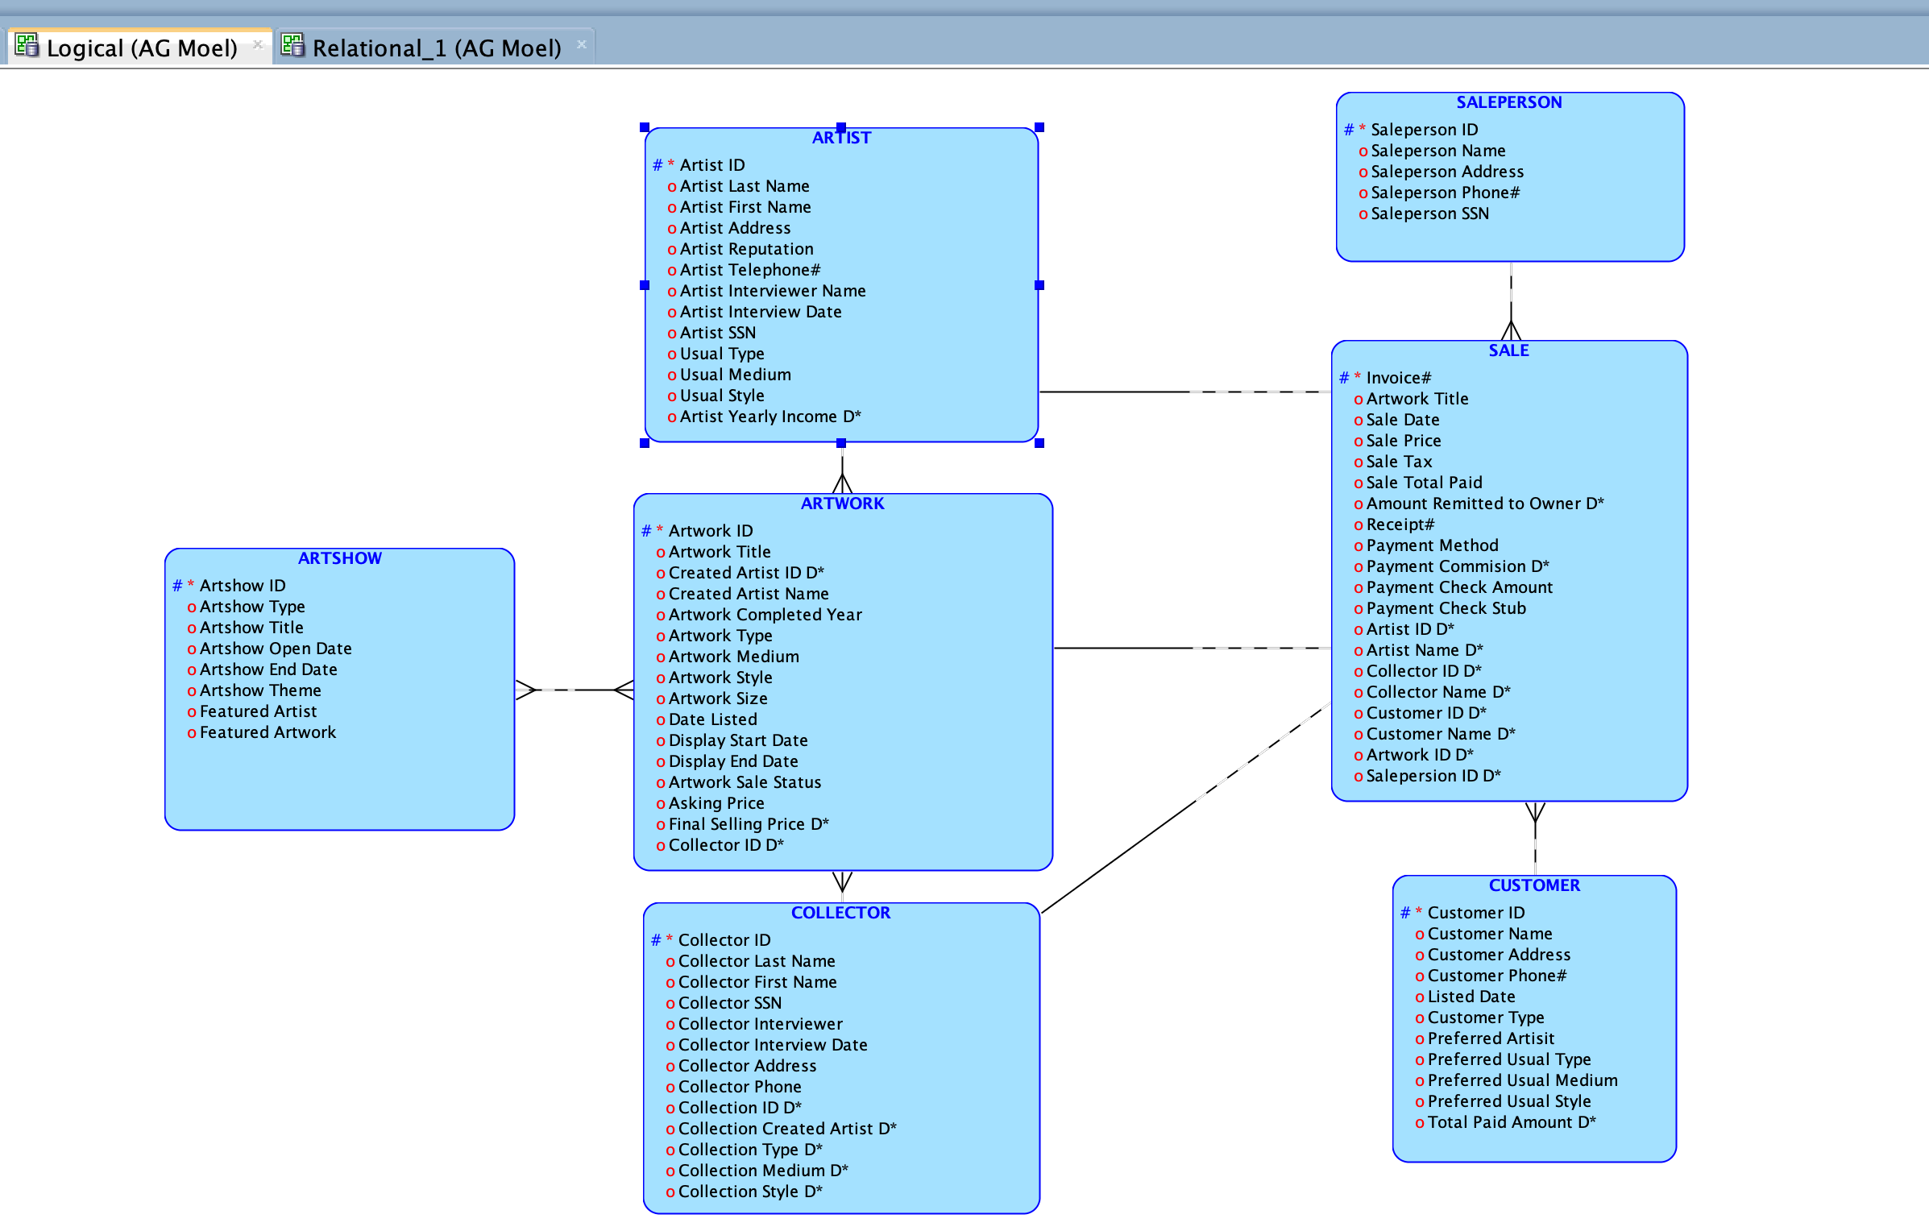

Figure1 E-R Diagram for Art Gallery Sales System

**Data dictionary for logical model**

* ARTSHOW

|  |  |  |  |  |  |
| --- | --- | --- | --- | --- | --- |
| Attribute | Primary Key | Type | Precision (size) | Units | Scale |
| Artshow ID | √ | NUMERIC | 10 |  | 0 |
| Artshow Type |  | CHAR | 20 | CHAR |  |
| Artshow Title |  | CHAR | 20 | CHAR |  |
| Artshow Open Date |  | Date |  |  |  |
| Artshow End Date |  | Date |  |  |  |
| Artshow Theme |  | CHAR | 20 | CHAR |  |
| Featured Artist |  | CHAR | 20 | CHAR |  |
| Featured Artwork |  | CHAR | 20 | CHAR |  |

* ARTIST

|  |  |  |  |  |  |
| --- | --- | --- | --- | --- | --- |
| Attribute | Primary Key | Type | Precision (size) | Units | Scale |
| Artist ID | √ | NUMERIC | 10 |  | 0 |
| Artist Last Name |  | CHAR | 20 | CHAR |  |
| Artist First Name |  | CHAR | 20 | CHAR |  |
| Artist Address |  | CHAR | 40 | CHAR |  |
| Artist Reputation |  | CHAR | 10 | CHAR |  |
| Artist Telephone# |  | Integer |  |  |  |
| Artist Interviewer Name |  | CHAR | 20 | CHAR |  |
| Artist Interview Date |  | Date |  |  |  |
| Artist SSN |  | Integer |  |  |  |
| Usual Type |  | CHAR | 20 | CHAR |  |
| Usual Medium |  | CHAR | 20 | CHAR |  |
| Usual Style |  | CHAR | 20 | CHAR |  |
| Artist Yearly Income D* |  | NUMERIC | 8 |  | 0 |

**Data dictionary for logical model**

* ARTWORK

|  |  |  |  |  |  |
| --- | --- | --- | --- | --- | --- |
| Attribute | Primary Key | Type | Precision (size) | Units | Scale |
| Artwork ID | √ | NUMERIC | 10 |  | 0 |
| Artwork Title |  | CHAR | 20 | CHAR |  |
| Created Artist ID D* |  | NUMERIC | 10 |  | 0 |
| Created Artist Name |  | CHAR | 20 | CHAR |  |
| Artwork Completed Year |  | Integer |  |  |  |
| Artwork Type |  | CHAR | 15 | CHAR |  |
| Artwork Medium |  | CHAR | 20 | CHAR |  |
| Artwork Style |  | CHAR | 20 | CHAR |  |
| Artwork Size |  | CHAR | 15 | CHAR |  |
| Date Listed |  | Date |  |  |  |
| Display Start Date |  | Date |  |  |  |
| Display End Date |  | Date |  |  |  |
| Artwork Sale Status |  | CHAR | 10 | CHAR |  |
| Asking Price |  | NUMERIC | 10 |  | 0 |
| Final Selling Price D* |  | NUMERIC | 10 |  | 0 |
| Collector ID D* |  | NUMERIC | 10 |  | 0 |

* COLLECTOR

|  |  |  |  |  |  |
| --- | --- | --- | --- | --- | --- |
| Attribute | Primary Key | Type | Precision (size) | Units | Scale |
| Collector ID | √ | NUMERIC | 10 |  | 0 |
| Collector Last Name |  | CHAR | 10 | CHAR |  |
| Collector First Name |  | CHAR | 20 | CHAR |  |
| Collector SSN |  | Integer |  |  |  |
| Collector Interviewer |  | CHAR | 20 | CHAR |  |
| Collector Interview Date |  | Date |  |  |  |
| Collector Address |  | CHAR | 20 | CHAR |  |
| Collector Phone |  | Integer |  |  |  |
| Collection ID D* |  | CHAR | 20 | CHAR |  |
| Collection Created Artist D* |  | CHAR | 20 | CHAR |  |
| Collection Type D* |  | CHAR | 20 | CHAR |  |
| Collection Medium D* |  | CHAR | 20 | CHAR |  |
| Collection Style D* |  | CHAR | 20 | CHAR |  |

**Data dictionary for logical model**

* SALE

|  |  |  |  |  |  |
| --- | --- | --- | --- | --- | --- |
| Attribute | Primary Key | Type | Precision (size) | Units | Scale |
| Invoice# | √ | NUMERIC | 10 |  | 0 |
| Artwork Title |  | CHAR | 20 | CHAR |  |
| Sale Date |  | Date |  |  |  |
| Sale Price |  | NUMERIC | 10 |  | 0 |
| Sale Tax |  | NUMERIC | 10 |  | 0 |
| Sale Total Paid |  | NUMERIC | 10 |  | 0 |
| Amount Remitted to Owner D* |  | NUMERIC | 10 |  | 0 |
| Receipt# |  | NUMERIC | 10 |  | 0 |
| Payment Method |  | CHAR | 20 | CHAR |  |
| Payment Commission D* |  | NUMERIC | 10 |  | 0 |
| Payment Check Amount |  | NUMERIC | 10 |  | 0 |
| Payment Check Stub |  | NUMERIC | 10 |  | 0 |
| Artist ID D* |  | NUMERIC | 10 |  |  |
| Artist Name D* |  | CHAR | 20 | CHAR |  |
| Collector ID D* |  | NUMERIC | 10 |  |  |
| Collector Name D* |  | CHAR | 20 | CHAR |  |
| Customer ID D* |  | NUMERIC | 10 |  |  |
| Customer Name D* |  | CHAR | 20 | CHAR |  |
| Artwork ID D* |  | NUMERIC | 10 |  |  |
| Saleperson ID D* |  | NUMERIC | 10 |  |  |

* SALEPERSON

|  |  |  |  |  |  |
| --- | --- | --- | --- | --- | --- |
| Attribute | Primary Key | Type | Precision (size) | Units | Scale |
| Saleperson ID | √ | NUMERIC | 10 |  | 0 |
| Saleperson Name |  | CHAR | 20 | CHAR |  |
| Saleperson Address |  | CHAR | 40 | CHAR |  |
| Saleperson Phone# |  | Integer |  |  |  |
| Saleperson SSN |  | Integer |  |  |  |

**Data dictionary for logical model**

* CUSTOMER

|  |  |  |  |  |  |
| --- | --- | --- | --- | --- | --- |
| Attribute | Primary Key | Type | Precision (size) | Units | Scale |
| Customer ID | √ | NUMERIC | 10 |  | 0 |
| Customer Name |  | CHAR | 20 | CHAR |  |
| Customer Address |  | CHAR | 40 | CHAR |  |
| Customer Phone# |  | Integer |  |  |  |
| Listed Date |  | Date |  |  |  |
| Customer Type |  | CHAR | 20 | CHAR |  |
| Preferred Artist |  | CHAR | 20 | CHAR |  |
| Preferred Usual Type |  | CHAR | 20 | CHAR |  |
| Preferred Usual Medium |  | CHAR | 20 | CHAR |  |
| Preferred Usual Style |  | CHAR | 20 | CHAR |  |
| Total Paid Amount D* |  | NUMERIC | 8 |  |  |

**List of assumptions for logical model**

**Assumptions：**

* Artist Yearly Income D* is the descriptive attribute between ARTIST and SALE.
* Final Selling Price D* is the descriptive attribute between ARTIST and ARTWORK.
* Collection ID D*, Collection Created Artist D*, Collection Type D*, Collection Medium D*, Collection Style D* are the descriptive attributes between COLLECTOR and ARTWORK.
* Payment Commission D*, Payment Check Amount D*, Payment Check Stub D*, Artist ID D*, Artist Name D*, Collector Name D*, Customer Name D* are the descriptive attributes between SALE and ARTWORK.
* Total Paid Amount D* is the descriptive attribute between CUSTOMER and SALE.

**Default Rational Model for Art Gallery Sales System**

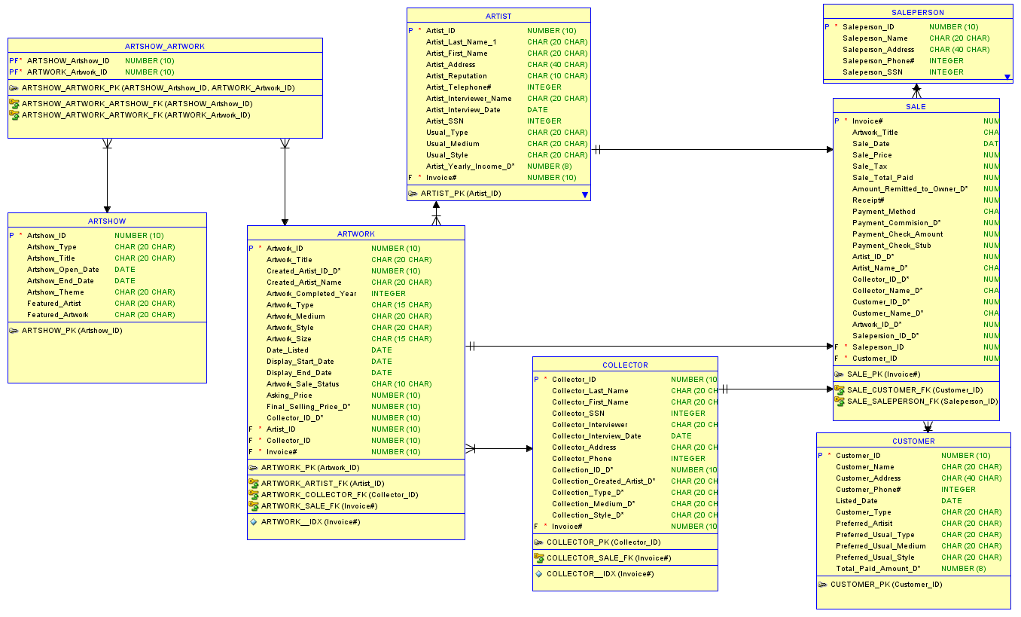

Figure2: Default Rational Model for Art Gallery Sales System

**Revised Rational Model for Art Gallery Sales System**

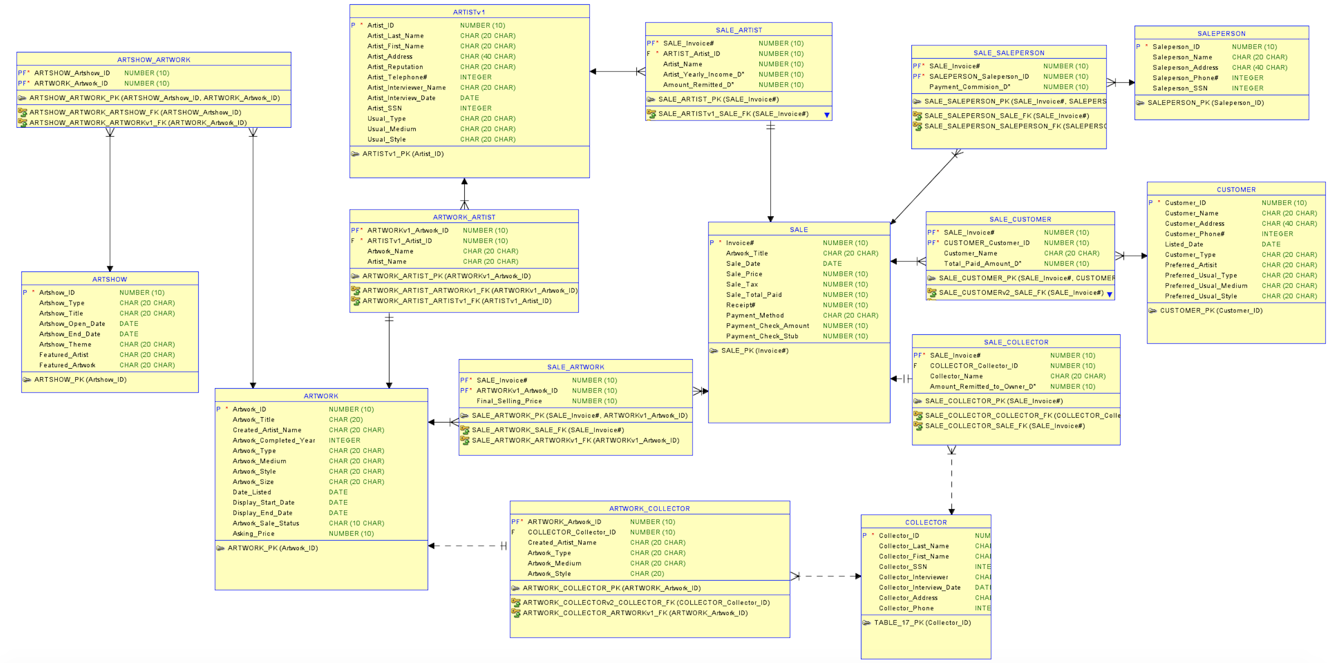

Figure3: Revised Rational Model for Art Gallery Sales System

**Data dictionary for relational model**

* ARTIST

|  |  |  |  |  |  |
| --- | --- | --- | --- | --- | --- |
| Attribute | Primary Key | Type | Precision (size) | Units | Scale |
| Artist ID | √ | NUMERIC | 10 |  | 0 |
| Artist Last Name |  | CHAR | 20 | CHAR |  |
| Artist First Name |  | CHAR | 20 | CHAR |  |
| Artist Address |  | CHAR | 40 | CHAR |  |
| Artist Reputation |  | CHAR | 10 | CHAR |  |
| Artist Telephone# |  | Integer |  |  |  |
| Artist Interviewer Name |  | CHAR | 20 | CHAR |  |
| Artist Interview Date |  | Date |  |  |  |
| Artist SSN |  | Integer |  |  |  |
| Usual Type |  | CHAR | 20 | CHAR |  |
| Usual Medium |  | CHAR | 20 | CHAR |  |
| Usual Style |  | CHAR | 20 | CHAR |  |

* ARTSHOW

|  |  |  |  |  |  |
| --- | --- | --- | --- | --- | --- |
| Attribute | Primary Key | Type | Precision (size) | Units | Scale |
| Artshow ID | √ | NUMERIC | 10 |  | 0 |
| Artshow Type |  | CHAR | 20 | CHAR |  |
| Artshow Title |  | CHAR | 20 | CHAR |  |
| Artshow Open Date |  | Date |  |  |  |
| Artshow End Date |  | Date |  |  |  |
| Artshow Theme |  | CHAR | 20 | CHAR |  |
| Featured Artist |  | CHAR | 20 | CHAR |  |
| Featured Artwork |  | CHAR | 20 | CHAR |  |

**Data dictionary for relational model**

* ARTWORK

|  |  |  |  |  |  |
| --- | --- | --- | --- | --- | --- |
| Attribute | Primary Key | Type | Precision (size) | Units | Scale |
| Artwork ID | √ | NUMERIC | 10 |  | 0 |
| Artwork Title |  | CHAR | 20 | CHAR |  |
| Created Artist Name |  | CHAR | 20 | CHAR |  |
| Artwork Completed Year |  | Integer |  |  |  |
| Artwork Type |  | CHAR | 15 | CHAR |  |
| Artwork Medium |  | CHAR | 20 | CHAR |  |
| Artwork Style |  | CHAR | 20 | CHAR |  |
| Artwork Size |  | CHAR | 15 | CHAR |  |
| Date Listed |  | Date |  |  |  |
| Display Start Date |  | Date |  |  |  |
| Display End Date |  | Date |  |  |  |
| Artwork Sale Status |  | CHAR | 10 | CHAR |  |
| Asking Price |  | NUMERIC | 10 |  | 0 |

* ARTSHOW-ARTWORK

|  |  |  |  |  |  |  |
| --- | --- | --- | --- | --- | --- | --- |
| Attribute | Primary Key | Type | Precision (size) | Units | Scale | Foreign  Key |
| Artshow ID | √ | NUMERIC | 10 |  | 0 | √ |
| Artwork ID | √ | NUMERIC | 10 |  | 0 | √ |

* ARTSHOW-ARTIST

|  |  |  |  |  |  |  |
| --- | --- | --- | --- | --- | --- | --- |
| Attribute | Primary Key | Type | Precision (size) | Units | Scale | Foreign  Key |
| Artwork ID | √ | NUMERIC | 10 |  | 0 |  |
| Artist ID |  | NUMERIC | 10 |  | 0 | √ |
| Artwork Name |  | CHAR | 20 | CHAR |  |  |
| Artist Name |  |  |  |  |  |  |

**Data dictionary for relational model**

* SALE

|  |  |  |  |  |  |
| --- | --- | --- | --- | --- | --- |
| Attribute | Primary Key | Type | Precision (size) | Units | Scale |
| Invoice# | √ | NUMERIC | 10 |  | 0 |
| Artwork Title |  | CHAR | 20 | CHAR |  |
| Sale Date |  | Date |  |  |  |
| Sale Price |  | NUMERIC | 10 |  | 0 |
| Sale Tax |  | NUMERIC | 10 |  | 0 |
| Sale Total Paid |  | NUMERIC | 10 |  | 0 |
| Receipt# |  | NUMERIC | 10 |  | 0 |
| Payment Method |  | CHAR | 20 | CHAR |  |
| Payment Check Amount |  | NUMERIC | 10 |  | 0 |
| Payment Check Stub |  | NUMERIC | 10 |  | 0 |

* SALE-ARTIST

|  |  |  |  |  |  |  |
| --- | --- | --- | --- | --- | --- | --- |
| Attribute | Primary Key | Type | Precision (size) | Units | Scale | Foreign  Key |
| Invoice# | √ | NUMERIC | 10 |  | 0 | √ |
| Artist ID |  | NUMERIC | 10 |  | 0 | √ |
| Artist Name |  | NUMERIC | 10 |  | 0 |  |
| Artist Yearly Income D* |  | NUMERIC | 10 |  | 0 |  |
| Amount Remitted D* |  | NUMERIC | 10 |  | 0 |  |

* SALE-ARTWORK

|  |  |  |  |  |  |  |
| --- | --- | --- | --- | --- | --- | --- |
| Attribute | Primary Key | Type | Precision (size) | Units | Scale | Foreign  Key |
| Invoice# | √ | NUMERIC | 10 |  | 0 | √ |
| Artist ID | √ | NUMERIC | 10 |  | 0 | √ |
| Final Selling Price |  | NUMERIC | 10 |  | 0 |  |

**Data dictionary for relational model**

* COLLECTOR

|  |  |  |  |  |  |
| --- | --- | --- | --- | --- | --- |
| Attribute | Primary Key | Type | Precision (size) | Units | Scale |
| Collector ID | √ | NUMERIC | 10 |  | 0 |
| Collector Last Name |  | CHAR | 10 | CHAR |  |
| Collector First Name |  | CHAR | 20 | CHAR |  |
| Collector SSN |  | Integer |  |  |  |
| Collector Interviewer |  | CHAR | 20 | CHAR |  |
| Collector Interview Date |  | Date |  |  |  |
| Collector Address |  | CHAR | 20 | CHAR |  |
| Collector Phone |  | Integer |  |  |  |

* SALE-COLLECTOR

|  |  |  |  |  |  |  |
| --- | --- | --- | --- | --- | --- | --- |
| Attribute | Primary Key | Type | Precision (size) | Units | Scale | Foreign  Key |
| Invoice# | √ | NUMERIC | 10 |  | 0 | √ |
| Collector ID |  | NUMERIC | 10 |  | 0 | √ |
| Collector Name D* |  | CHAR | 20 | CHAR |  |  |
| Amount Remitted to Owner D* |  | NUMERIC | 10 |  | 0 |  |

* ARTWORK-COLLECTOR

|  |  |  |  |  |  |  |
| --- | --- | --- | --- | --- | --- | --- |
| Attribute | Primary Key | Type | Precision (size) | Units | Scale | Foreign  Key |
| Artwork ID | √ | NUMERIC | 10 |  | 0 | √ |
| Collector ID |  | NUMERIC | 10 |  | 0 | √ |
| Created Artist Name D* |  | CHAR | 20 | CHAR |  |  |
| Artwork Type D* |  | CHAR | 20 | CHAR |  |  |
| Artwork Medium D* |  | CHAR | 20 | CHAR |  |  |
| Artwork Style |  | CHAR | 20 | CHAR |  |  |

**Data dictionary for relational model**

* SALEPERSON

|  |  |  |  |  |  |
| --- | --- | --- | --- | --- | --- |
| Attribute | Primary Key | Type | Precision (size) | Units | Scale |
| Saleperson ID | √ | NUMERIC | 10 |  | 0 |
| Saleperson Name |  | CHAR | 20 | CHAR |  |
| Saleperson Address |  | CHAR | 40 | CHAR |  |
| Saleperson Phone# |  | Integer |  |  |  |
| Saleperson SSN |  | Integer |  |  |  |

* SALE-SALEPERSON

|  |  |  |  |  |  |  |
| --- | --- | --- | --- | --- | --- | --- |
| Attribute | Primary Key | Type | Precision (size) | Units | Scale | Foreign  Key |
| Invoice# | √ | NUMERIC | 10 |  | 0 | √ |
| Saleperson ID | √ | NUMERIC | 10 |  | 0 | √ |
| Payment Commission D* |  | NUMERIC | 10 |  |  |  |

* CUSTOMER

|  |  |  |  |  |  |
| --- | --- | --- | --- | --- | --- |
| Attribute | Primary Key | Type | Precision (size) | Units | Scale |
| Customer ID | √ | NUMERIC | 10 |  | 0 |
| Customer Name |  | CHAR | 20 | CHAR |  |
| Customer Address |  | CHAR | 40 | CHAR |  |
| Customer Phone# |  | Integer |  |  |  |
| Listed Date |  | Date |  |  |  |
| Customer Type |  | CHAR | 20 | CHAR |  |
| Preferred Artist |  | CHAR | 20 | CHAR |  |
| Preferred Usual Type |  | CHAR | 20 | CHAR |  |
| Preferred Usual Medium |  | CHAR | 20 | CHAR |  |
| Preferred Usual Style |  | CHAR | 20 | CHAR |  |

* SALE-CUSTOMER

|  |  |  |  |  |  |  |
| --- | --- | --- | --- | --- | --- | --- |
| Attribute | Primary Key | Type | Precision (size) | Units | Scale | Foreign  Key |
| Invoice# | √ | NUMERIC | 10 |  | 0 | √ |
| Customer ID | √ | NUMERIC | 10 |  | 0 | √ |
| Customer Name |  | CHAR | 20 | CHAR |  |  |
| Total Paid Amount D* |  | NUMERIC | 10 |  |  |  |

**List of assumptions for revised relational model**

**Assumptions：**

* Descriptive attributes below are into the appropriate tables:
  + Artist Yearly Income D* is the descriptive attribute between ARTIST and SALE.
  + Final Selling Price D* is the descriptive attribute between ARTIST and ARTWORK.
  + Collection ID D*, Collection Created Artist D*, Collection Type D*, Collection Medium D*, Collection Style D* are the descriptive attributes between COLLECTOR and ARTWORK.
  + Payment Commission D*, Payment Check Amount D*, Payment Check Stub D*, Artist ID D*, Artist Name D*, Collector Name D*, Customer Name D* are the descriptive attributes between SALE and ARTWORK.
  + Total Paid Amount D* is the descriptive attribute between CUSTOMER and SALE.
* Keep all relationship tables with descriptive attributes (1:1, 1: M, M: 1 & M: N).
* If relationship is 1:1 either unique identifier can be primary key.
* Both unique identifiers together become the primary key of the M: N table.